MS.NET
Mini Project
e-Commerce Shopping Store
(eCSS)

Document Revision History

Date | Revision No. | Author | Summary of Changes
20th Nov. 2008 | 1 | Ganesh Desai | Initial Draft
15th Dec 2008 | 1 | Anil Patil | Review
25th July 2011 | 1 | Karthik | Review after integration Process
11th May 2015 | 1 | Vaishali Kasture | Modifications as per new curriculum
13th July 2016 | 1 | Vijay Vishwakarma | Incorporating changes as per new curriculum

Table of Contents
Introduction 4
Setup Checklist 4
Instructions 4
Problem Statement 5
Objective 5
Abstract of the project 5
Functional components of the project 6
Technology used: 7
Implementation 8
Summary of the functionality to be built: 8
Guidelines on the functionality to be built: 9

Introduction

This document outlines a mini project for the .NET Line of Technology (LOT). The project is to develop online Shopping Store ecommerce Application. This document contains the requirements, work flow of the system and gives guidelines on how to build the functionality gradually in each of the course modules of the .NET LOT.

Setup Checklist
Minimum System Requirements
- Intel Pentium 4 and above Windows XP, 2000 and 2003
- Memory 1 GB
- Internet Explorer 6.0 or higher
- SQL Server 2012 client and access to SQL Server 2012 server
- Visual Studio 2013

Instructions
- The code modules in the mini project should follow all the coding standards.
- Create a directory by your name in drive <drive>. In this directory, create a subdirectory MiniProject. Store your Project here.
- You can refer to your course material.
- You may also look up the help provided in the MSDN
- Since this project work will span over couple of months, you will need to take care of maintaining the code

Problem Statement

Objective
Development of online Shopping Store eCommerce Application (eCSS)

Abstract of the project
CyberShopee wants to set up On Line shopping facility for their Customers. They sell various products belonging to various categories. E.g they have Electronics Items Category having products like TV, Camera etc.

This Online shopping Application should provide the following features to the customers:
- Customer Registration
- View Product Details
- Purchase Products
- Confirm the Order

Note: Other that First Time registration, the other operations are allowed only for registered customers.

Once the Order is confirmed, Cyber shopee will deliver the ordered products to the customer on his address specified during the registration. The Payment mode will be Cash On Delivery.

Develop the Application for the above requirement using MS.NET Technology.

Functional components of the project
Application Architecture:
Distributed web applications traditionally to be designed and built across three logical tiers:
- Database Access Layer (DAL)
- Business Logic Layer (BLL)
- Presentation Layer

The DAL refers to the database itself, the stored procedures, and the component that provides an interface to the database. The BLL refers to the component that encapsulates all the business logic of the application. And, the Presentation layer refers to the web application pages.

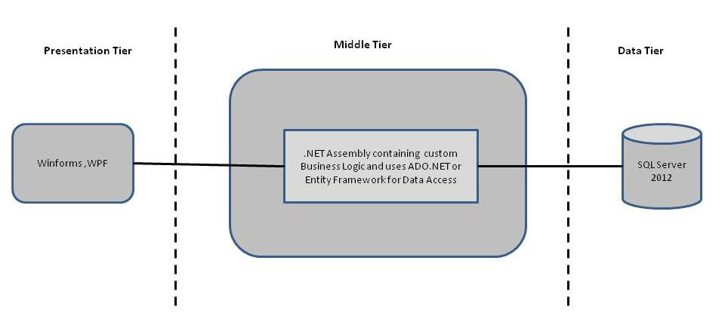

- Design guidelines
- Presentation layer comprises of Winforms and WPF
- Data access layer of 3-tier useADO.NET data access using SQL stored procedures - All the database interaction would be performed using Data Access Component. Most common methods in Data Access Component would be –
- Create Connection to the Database
- Create Command Object
- Set Command Type to Stored Procedure
- Create and Populate Parameters
- Execute the Command
- Close the Connection

Technology used:
    - Presentation Layer
        - Winforms 4.5
        - WPF 4.5

    - Business Layer
      - Business Logic Components and Services :-
        - C# 5.0

    - Database Layer
      - Databases:-
        - SQL Server 2012

Note: Saturday half day will be devoted for mini project

Implementation

Summary of the functionality to be built:
The participants need to develop the Online Shopping Cart Application by building the functionality incrementally in each of the course modules of .NET LOT.

Sr. No | Course | Duration | Functionality to be built
Sr. No | Course | (in PDs) | Functionality to be built
1 | MS SQL Server 2012 | 4 | Creating relevant database tables and stored procedures
2 | NET Framework 4.5 + C# 5.0 | 7.5 | Developing Business components (C# classes)
3 | Winforms 4.5 | 1 | Designing the user interface
4 | ADO.NET 4.5 | 3 | Integrating the DAL and BLL And PL
5 | LINQ and Entity Framework | 2 | Creating data model and data context and using LINQ to Entities
5 | WPF 4.5 | 2 | Incorporating advanced UI functionality with WPF 4.5
6 | Mini Project Presentation | 1 | The Mini Project Presentation day

Guidelines on the functionality to be built:

The functionality and components to be built in each of the course modules of .NET LOT is as follows:
- Course: SQL Server 2012
This section describes some of the basic steps involved in designing and creation of the database for the application.

Create Data Model - identify the different tables and fields that we will need, which would later be used for building the rest of the application.

Database Schema - In order to design the database schema, we needed to look at the requirements of the application. In our application, we are going to have a product catalog that customers can browse and add items to their shopping cart. So, taking these high level requirements, we can quickly and easily identify the tables and stored procedures in our database by simply identifying many of the verbs and nouns in some of the below user cases:
- Customers can add a given product to the shopping cart.
- Customers can view products by category.
- Customers can checkout the shopping cart to place an order.
Out of these user cases, we can identify a number of objects, which are nouns in our sentences.
- Customers
- Products
- Shopping Cart
- Categories
- Orders

Taking these objects, we can easily identify our main tables in the database.

  - Create the following database tables:
    - Customers: This will contain the list of Customers.
    - Products: This contains the list of products available in the shopping store for purchase.
    - Categories: This will contain various Categories for the Products available.
    - Orders: This will contain the Master details of Orders.
    - OrderDetails: This will contain the details of the Products Ordered.
    - Shopping Cart: This table will store the details about the Cart.
  - The structure of the above listed tables is as follows:
    - Customers: Customer Id, Full Name, Email Address, Password, delivery address
    - Products: ProductsId, CategoryId, ModelNumber, ModelName, Unit Cost, Description
    - Categories: CategoryId, Category Name, Description
    - Orders: OrderId, CustomerId, OrderDate, ShipDate
    - OrderDetails: OrderId, ProductId, Quantity, UnitCost
    - ShoppingCart: RecordId, CartId, Quantity, ProductId, DateCreated

- Course: Winforms 4.5,WPF 4.5
  - Develop the prototypes for following functionalities:
    - Login / Sign In: Login screen would display asking user to enter ‘User Id’ & ‘Passwd’. If the supplied user credentials are valid the HomePage would be displayed, else appropriate Login error message would be displayed
    - First time users Register: First time new users would use this screen to create their profile (userId and password). On click of ‘Submit’ button new user entry (user id & password) would be saved into database table for further user authentication purpose
    - Home Page: On successful user authentication (validation of userid/password provided by the user in login screen) the homepage would be displayed. The Homepage would contain below sections/contents:

Header section: The header section would be common across all the pages and would mainly have –

Sign In Link – On click it would take to Login page

Account Link – On click it would take to Account History page which displays all the shopping carts details by the logged in user.

Cart Link – On click it would take to Shopping Cart screen which displays the cart details of the current active Shopping Cart. If no active cart then display message “No Active Cart found.”

Main content section: It would display generic Welcome message giving overview of the site. Also it would display links/images of the most popular product items, on click of popular item link the Product Detail screen would be displayed showing the product description, amount and option of adding the item to the cart. Also a link to Category Page should be displayed, which will display all the categories and allow the user to select the product from that specific category.

    - Category View and select product: This screen allows the customers to see all the categories and select the category to purchase the product from that category. Depending upon the selection, It should go to Product Details screen displaying the details about the products in that category.
    - Product Detail: This screen allows the Customers to see the products from the selected category. It should provide the option to Add select product to Cart.
    - Shopping Cart: It would display all the products added to cart, below fields are to be displayed for each added product.
- Product Id
- Product Name
- Model
- Quantity – User can change the quantity of any product
- Price
- Sub-total (Price * Quantity)
- Total Amount

Remove option for removing any of the products from the shopping cart.

Update Shopping cart – This link to be provided for updating the shopping cart (sub-total amount, selected items to be removed). On click of this link the page would be refreshed with the updated subtotal amount (i.e. Quantity * Price)

Final Check Out – This link would be used by the user to do the final check out (for confirmation and submission of the order)

  - In this course you need to develop the user interface using Winforms and WPF.The screens should include the fields as per the functionality mentioned above. Include Validations where ever required.
- Course: C# 5.0 and ADO.NET 4.5
  - Develop business components (C# classes) for the following functionality:
    - Customers Class: The Customers class contains the methods that pertain to the shopper. The process begins with the User Authentication. If the Customer does not exists in the database, Then the class allows to Add a new Customer in the customer table.
    - Product Class: This class will handle access to the Categories and Products table in the database. The class will provide functionality to retrieve the data from Categories Table. The Categories table maps to the Products table, which contains all of the available products for which the user can shop. The class will also provide functionality to return the set of products that corresponds to the selected category.
    - Shopping Cart Class: This class is the most important class in the whole project. Keeping track of what the user wants to buy is very important. This class is used to maintain the Shopping Cart information.
    - User verification (xml data store): Develop a component to replace the class that does user verification to perform authentication against an XML data store (i.e. the user details are in xml file instead of database). The component should be easily pluggable.

You need to create Layered Architecture which comprises of PresentationLayer (winforms,WPF),Business Logic Layer (C# Classes) and DAL Layer(Using ADO.Net 4.5 or Linq and Entity Framework)

DAL Layer of ADO.NET 4.5 will include all the required code snippets for CRUD Operations.

All the CRUD operations should use SQL Server Stored Procedures(For Insert,Update,Delete & Search).

The connectionString should be stored in the configuration file only.
OR

- Course: LINQ and EF
  - Using Database First Approach create the entity data model form the database created in the earlier steps. The model will consist of the following entities
    - Customer :- This entity/class will have fields for storing Customer details
    - Products :- This entity/class will have fields for storing Products details
    - Categories :- This entity/class will have fields for storing categories details
    - Orders :- This entity/class will have fields for storing Orders information
    - OrdersDetails :- This entity/class will have fields for storing details of orders form the orders entity
    - ShoppingCart :- This entity/class will have fields for storing the shopping cart details
  - Use data context to perform the CRUD operations and implement required logic using LINQ( like retrieving data, sorting data, searching data etc)

- Course: ADO.NET 4.5 and Winforms 4.5 ,WPF 4.5
  - Integrate all screens (Winforms ,WPF ) with business components (C# classes) to complete the entire functionality.

Project Evaluation Guidelines
The project it is to be evaluated based on the following five parameters:

- Proper Database Structure and UI designing as per the specifications –(15 Marks)
  - Proper Database Design and Stored Procedure
  - Visual look and feel of the UI
- Project Completion – (20 Marks)
  - Timely Completion of the project
  - Integration of all component of the system
- Defect free execution – (30 Marks)
  - Error free execution of individual modules and the whole system
  - Validation
  - Functionality as per the specified requirements
- Compliance of standard and guidelines – (15 Marks)
  - Appropriate comments entries
  - Adherence to naming conventions for classes, functions, variables and files
  - Simplicity of user interface and screen layouts
  - Maintainability of codes (for example, no one function should be more than 100 lines)
- Group Presentation and Query handling – (20 Marks)
  - Participants (Group of 3 to 4) to present the project with UML Diagrams(use case diagram and one of the sequence or activity diagram) and PPT

